ES Chapter 2 Matter Lab

Elements and Molecules

Element List:
Hydrogen – white
Oxygen – red
Nitrogen – blue
Chlorine – green
Carbon – black
Sulphur – yellow
Sodium – Metallic (one hole)

Using the ball and stick models provided, and some help from your book or the internet, create the following molecules. Short grey bonds represent single bonds, longer grey bonds are used when multiple (double & triple) bonds are needed.

*Draw a picture of each molecule and label it with its name and chemical formula
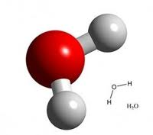
Example:Water = H₂O

- Ethanol – C₂H₆O
- Nitrogen trifluoride – NF₃
- Carbon dioxide – CO₂
- Diatomic oxygen – O₂
- Methane – CH₄
- Diatomic Nitrogen – N₂
- Tetrochlorocyclopropane – C₃Cl₆
- Hydrogen peroxide – H₂O₂
- Sulfur dioxide – SO₂
- Nitrous oxide – N₂O

Challenge
- Sugar – C₆H₁₂O₆
- Benzene – C₆H₆ (ring)

